Mid_term_exam

Mo Pei

10/23/2016

Question 1. 1

Question 2. 3

Question 3. 7

Question 4. 9

Question 5. 14

This file includes the R script and its results. The outcome of each R script is highlighted as bolded ‘**Result’** in order to read this document easier. Thank you!

#packages set up  
# install.packages('moments')  
# install.packages('boot')  
# install.packages('logspline')  
library(boot)  
library(logspline)  
library(quantmod)

# Question 1.

n<-1000  
  
simu_bonus<-1:n  
for(i in 1:n)  
{  
 gs4<-sample(c('<=4','>4'),1,prob=c(0.6,0.4))  
   
 if(gs4=='>4')  
 {  
 n_bi<-sample(c(5,6,7,8),1,prob=c(0.35,0.45,0.15,0.05))  
 bonus<-1:n_bi  
   
 for(j in 1:n_bi)  
 {  
 bonus[j]<-sample(c(10,15,20,25),1,prob=c(0.40,0.35,0.20,0.05))   
 }  
 simu_bonus[i]<-sum(bonus)  
 }  
 else   
 {  
 simu_bonus[i]<-0  
 }  
  
}  
  
hist(simu_bonus,probability = TRUE)  
abline(v=mean(simu_bonus),col='Brown')

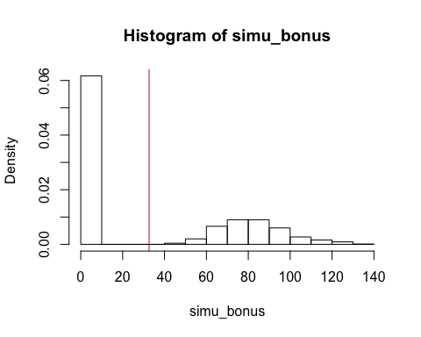

mean_simu_bo<-mean(simu_bonus)  
sd_simu_bo<-sd(simu_bonus)  
  
cat('The 95% confidence interval of the expected value of bonus is bewteen ',mean_simu_bo-1.96*(sd_simu_bo/sqrt(n)) ,' and ', mean_simu_bo+1.96*(sd_simu_bo/sqrt(n)),'\n')

**Result:**

the bonus a salesperson can expect in a day is 35.815 and standard deviation is

The 95% confidence interval of the expected value of bonus is bewteen 29.98389 and 35.27611

# Question 2.

a.

er=c(0.24, 0.15) covmat=matrix(c(0.32^2, 0.21*0.32*0.1, 0.21*0.32*0.1, 0.21^2 ),nrow=2,ncol=2) names(er)=c("Stock_fund","Bond_fund") colnames(covmat)=c("Stock_fund","Bond_fund") rownames(covmat)=c("Stock_fund","Bond_fund")

gmin.port <- globalMin.portfolio(er, covmat)

**Result:**

The risk and return of the minimum variance portfolio consisting of the stock and bond funds are below

Portfolio expected return: 0.1752833

Portfolio standard deviation: 0.1833003

Portfolio weights:

Stock_fund Bond_fund

0.2809 0.7191

b.

ef=efficient.frontier(er,covmat) plot(ef $sd,ef$ er,type="l",xlab="risk",ylab="return") msharp=0

**Result:**

A plot of the efficient frontier, allowing short sales.

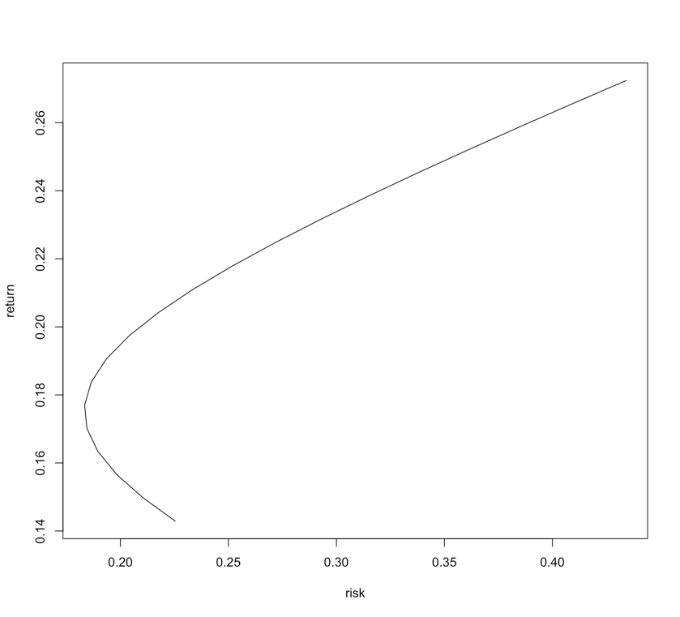

c.

rk.free=.05  
tan.port <- tangency.portfolio(er, covmat, rk.free)  
print(tan.port)  
summary(tan.port, risk.free=rk.free)  
plot(tan.port)   
  
plot(ef$sd,ef$er,type="l",xlab="risk",ylab="return")  
abline(a=rk.free, b=0.7266561)

**Result:**

The weights for the tangent portfolio, as well as the risk and return of the tangent portfolio.

Portfolio expected return: 0.191609

Portfolio standard deviation: 0.1948776

Portfolio Sharpe Ratio: 0.7266561

Portfolio weights:

Stock_fund Bond_fund

0.4623 0.5377

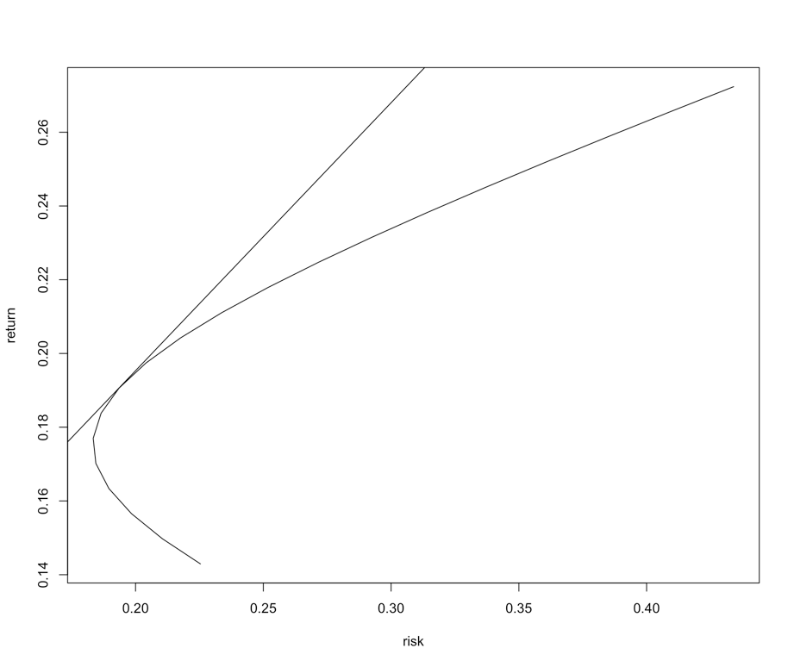

d.

**Result:**

When allowing short sell, the appropriate portfolio weights and the resulting portfolio standard deviation are below.



The reduction in standard deviation could you attain if instead you used the money market fund and the tangent portfolio to construct a portfolio that returned .28

Firstly, we maximized the sharpe ratio, and then formed a new portfolio

that has risk and risky assets. From the results below, we can conclude that the sd of the portfolio is decreased by 0.15.





# Question 3.

a.

**Result:**

mikeline_new=function(x,y) {  
xmed=median(x)  
xbar1=median(x[x<=xmed])  
ybar1=median(y[x<=xmed])  
xbar2=median(x[x>xmed])  
ybar2=median(y[x>xmed])  
slope = (ybar2-ybar1)/(xbar2-xbar1)  
inter = ybar1-slope*xbar1  
cat("Intercept = ",inter," Slope = ",slope,"\n")  
return(slope)  
}

b.

getSymbols("IBM", from = "2013-09-01")

getSymbols("SPY", from="2013-09-01")

spyret=as.numeric(monthlyReturn(SPY))  
ibmret=as.numeric(monthlyReturn(IBM))  
  
fit<-lm(ibmret~spyret)  
summary(fit)

##   
## Call:  
## lm(formula = ibmret ~ spyret)  
##   
## Residuals:  
## Min 1Q Median 3Q Max   
## -0.142225 -0.021226 0.000059 0.023327 0.118702   
##   
## Coefficients:  
## Estimate Std. Error t value Pr(>|t|)   
## (Intercept) -0.009522 0.008012 -1.189 0.2424   
## spyret 0.755184 0.254412 2.968 0.0053 **  
## ---  
## Signif. codes: 0 '***' 0.001 '**' 0.01 '*' 0.05 '.' 0.1 ' ' 1  
##   
## Residual standard error: 0.04804 on 36 degrees of freedom  
## Multiple R-squared: 0.1966, Adjusted R-squared: 0.1743   
## F-statistic: 8.811 on 1 and 36 DF, p-value: 0.005297

cat('The valueu of Beta by using least squares :',coef(fit)[2] ,'\n')

**Result:**

The valueu of Beta by using least squares : 0.7551839

new_slope<-mikeline_new(spyret,ibmret)

## Intercept = -0.00698411 Slope = 0.4361206

cat('The valueu of Beta by using modified algorithm : ' ,new_slope,'. The value is off by ',coef(fit)[2] , 'the value of least square method.' ,'\n')

**Result:**

## The valueu of Beta by using modified algorithm : 0.4361206 . The value is off by 0.7551839 the value of least square method.

c.

**Result:**

myfunc<-function(data,i) {  
   
x=data[i,1]  
y=data[i,2]  
  
xmed=median(x)  
xbar1=median(x[x<=xmed])  
ybar1=median(y[x<=xmed])  
xbar2=median(x[x>xmed])  
ybar2=median(y[x>xmed])  
slope = (ybar2-ybar1)/(xbar2-xbar1)  
# inter = ybar1-slope*xbar1  
# cat("Intercept = ",inter," Slope = ",slope,"\n")  
return(slope)  
}  
  
mydata=cbind(spyret,ibmret)  
bfit=boot(mydata,myfunc,R=1000)  
boot.ci(bfit)

## Warning in boot.ci(bfit): bootstrap variances needed for studentized  
## intervals

## BOOTSTRAP CONFIDENCE INTERVAL CALCULATIONS  
## Based on 1000 bootstrap replicates  
##   
## CALL :   
## boot.ci(boot.out = bfit)  
##   
## Intervals :   
## Level Normal Basic   
## 95% (-0.6369, 1.3011 ) (-0.9008, 1.0360 )   
##   
## Level Percentile BCa   
## 95% (-0.1637, 1.7731 ) (-0.1165, 1.8392 )   
## Calculations and Intervals on Original Scale

**Result:**

cat('The bootstrap 95% confidence interval is between ',boot.ci(bfit)$percent[4],' and ',boot.ci(bfit)$percent[5])

## The bootstrap 95% confidence interval is between -0.163711 and 1.773088

# Question 4.

a.

mystocks=read.csv("http://people.fas.harvard.edu/~mparzen/stat107/dow30.csv",header=FALSE,colClasses="character")

**Result:**

getSymbols("SPY",from="2013-09-01",to ="2016-09-01")

## [1] "SPY"

spyret=as.numeric(monthlyReturn(SPY))  
  
all_beta<-1:nrow(mystocks)  
all_sd<-1:nrow(mystocks)  
for(i in 1:length(all_beta))  
{  
 stock_obj<-getSymbols(mystocks[i,1], from = "2013-09-01",to ="2016-09-01",auto.assign=FALSE)  
 stock_obj_ret=as.numeric(monthlyReturn(stock_obj))  
   
 fit<-lm(stock_obj_ret~spyret)  
 all_beta[i]<-coef(fit)[2]  
 all_sd[i]<-sd(stock_obj_ret)  
}  
  
cat('The beta of the stocks in mystocks is ',all_beta,'\n')

## The beta of the stocks in mystocks is 1.261771 1.335803 1.258655 1.335971 1.140272 1.148486 1.802246 0.7775952 1.199146 1.212417 1.02034 0.7355329 1.095351 0.6740743 0.794923 1.05718 0.6023883 0.9681937 0.7674213 1.349803 0.9111244 0.9519475 0.5915899 1.155403 0.5337071 0.910551 0.5362807 1.726484 0.08965563 1.408918

b.

**Result:**

cat('The standard deviation of the stocks in mystocks is ',all_beta,'\n')

## The standard deviation of the stocks in mystocks is 1.261771 1.335803 1.258655 1.335971 1.140272 1.148486 1.802246 0.7775952 1.199146 1.212417 1.02034 0.7355329 1.095351 0.6740743 0.794923 1.05718 0.6023883 0.9681937 0.7674213 1.349803 0.9111244 0.9519475 0.5915899 1.155403 0.5337071 0.910551 0.5362807 1.726484 0.08965563 1.408918

c.

**Result:**

plot(all_beta,all_sd,main = 'Scatter plot of beta and sd',xlab = 'Beta',ylab = 'Standard Deviation')

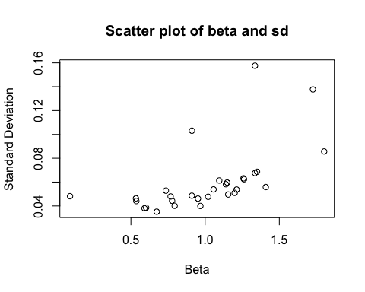

d.

**Result:**

cor(all_sd,all_beta)

## [1] 0.5762182

cat('Beta and standard deviation are positively correlated. The larger Beta means more variation when the index changes')

## Beta and standard deviation are positively correlated. The larger Beta means more variation when the index changes

e.

**Result:**

fit_beta_sd<-lm(all_sd~all_beta)  
summary(fit_beta_sd)

##   
## Call:  
## lm(formula = all_sd ~ all_beta)  
##   
## Residuals:  
## Min 1Q Median 3Q Max   
## -0.021704 -0.010585 -0.006993 -0.001862 0.083242   
##   
## Coefficients:  
## Estimate Std. Error t value Pr(>|t|)   
## (Intercept) 0.01613 0.01255 1.285 0.209200   
## all_beta 0.04359 0.01168 3.731 0.000861 ***  
## ---  
## Signif. codes: 0 '***' 0.001 '**' 0.01 '*' 0.05 '.' 0.1 ' ' 1  
##   
## Residual standard error: 0.0231 on 28 degrees of freedom  
## Multiple R-squared: 0.332, Adjusted R-squared: 0.3082   
## F-statistic: 13.92 on 1 and 28 DF, p-value: 0.0008609

**Result:**

cat('According to the regression output, Intercept p value is 0.209200 which is not significant, and slope p value is 0.000861 is smaller than 0.05 which is significant.')

## According to the regression output, Intercept p value is 0.209200 which is not significant, and slope p value is 0.000861 is smaller than 0.05 which is significant.

**Result:**

cat('According to the regression output, 33.2% of  
standard deviation’s variability is explained by Beta  
movements.')

## According to the regression output, 33.2% of  
## standard deviation’s variability is explained by Beta  
## movements.

f.

all_beta<-1:nrow(mystocks)  
all_rsquare<-1:nrow(mystocks)  
for(i in 1:length(all_beta))  
{  
 stock_obj<-getSymbols(mystocks[i,1], from = "2013-09-01",to ="2016-09-01",auto.assign=FALSE)  
 stock_obj_ret=as.numeric(monthlyReturn(stock_obj))  
   
 fit<-lm(stock_obj_ret~spyret)  
 all_beta[i]<-coef(fit)[2]  
 all_rsquare[i]<-summary(fit)$r.squared  
}  
  
plot(all_beta,all_rsquare,main = 'Scatter plot of beta and r squared',xlab = 'Beta',ylab = 'r squared')

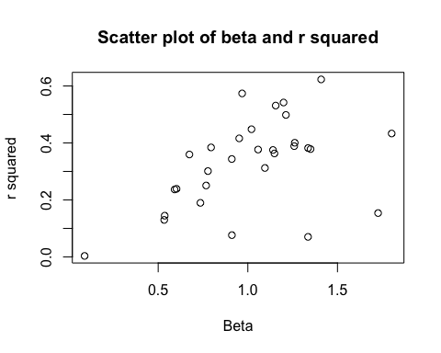

**Result:**

cat('For single factor linear model, the R squred expresses the amount of variation explained by x. The rise of Beta would increase the variablity of x')

## For single factor linear model, the R squred expresses the amount of variation explained by x. The rise of Beta would increase the variablity of x

# Question 5.

Since Cov(Ri,Rj) = sigma_m^2 * beta_i * beta_j

Cov(Rp,Rm) = sigma_m^2 * beta_p * beta_m

beta_m=1

Cov(Rp,Rm) = sigma_m^2 * beta_p

beta_p = Cov(Rp,Rm) / sigma_m^2

Since Covariance property below,



Cov(Rp,Rm)=Cov(xa*Ra+xb*Rb,Rm)

=Cov(xa*(αA +βA*RM +εA)+xb*( αB +βB*RM

+εB), Rm)

=Cov(xa*αA+xb* αB,

Rm)+Cov(xa*βA*Rm+xb*βB*Rm, Rm)+

Cov(xa*εA+xb*εB,Rm)

= 0 + Cov(xa*βA*Rm+xb*βB*Rm, Rm)+0

= Cov(Rm(xa*βA+xb*βB),Rm)

=( xa*βA+xb*βB )Cov(Rm,Rm)

Since Cov(Rm,Rm)=Var(Rm)

Cov(Rp,Rm) =(xa*βA+xb*βB) Var(Rm)

beta_p =( xa*βA+xb*βB )Var(Rm) / sigma_m^2

beta_p= xa*βA+xb*βB